Student’s name Class Date

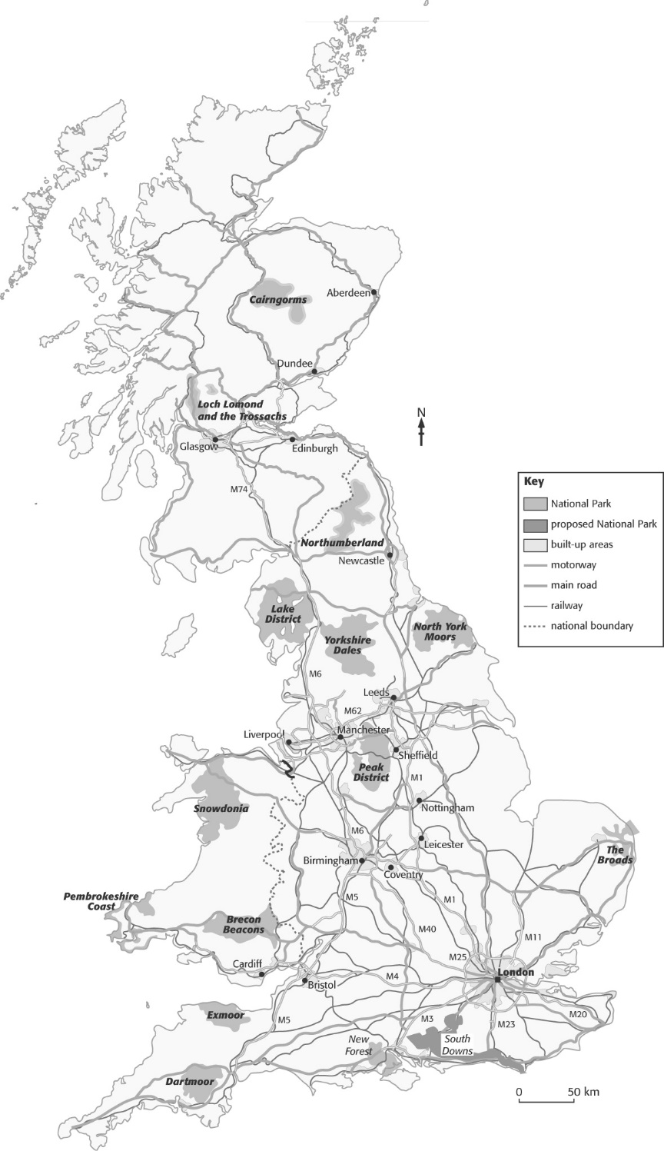
Background about Dartmoor

Dartmoor occupies approximately 1000 square kilometres in South-West England. It’s a mixture of open moorland, forests and farmland. Dartmoor is also one of the National Parks of England and Wales (look at the map).

Along with the other National Parks, and many other countryside areas, Dartmoor is under pressure from different land uses. These land uses sometimes conflict with one another, and they aren’t always beneficial to the natural environment.

◆ The highest part of central Dartmoor is used for military training exercises, some using live ammunition. The National Park Authority has often stated that it considers that military use is not appropriate for land in a National Park.
◆ There is a demand for increasing water supply in South-West England. Dartmoor has no natural lakes, so a series of reservoirs has been constructed to supply nearby settlements, such as Plymouth and Exeter. Despite the growing demand, the National Park Authority has refused to grant permission for the creation of further reservoirs.
◆ Mining has taken place in Dartmoor for centuries. China clay, or kaolin, remains an important resource, used in the manufacture of porcelain. The mining of china clay produces large quantities of waste, which is dumped near the large open-cast quarries. Such industry has a major negative impact on the scenery of the National Park.
◆ The fastest-growing pressure on Dartmoor is from tourism. Although one of the least accessible of the National Parks, Dartmoor still receives more than 10 million visitors each year. Most of these visitors are from the South-West of England, and, until recently, the majority of them visited Dartmoor on day trips. As the centre of the Park is not easily accessible, the greatest pressure is currently on the two roads that follow the northern and southern edges of Dartmoor.

As the Park becomes more popular, however, it’s probable that the number of people wanting to stay in Dartmoor, rather than just visit for the day, will increase. This will lead to an increased demand for accommodation of a variety of types to suit different visitors. This extra accommodation will mean demand for more roads, more water and electricity use, and extra tourist facilities such as restaurants and shops (providing employment for local people).

The proposed development

Moor Holidays is an organisation that provides self-catering holidays in purpose-built holiday villages. Typically, these holiday villages provide a range of leisure activities in a self-contained and purpose-built complex.

Moor Holidays have put forward a planning request to build a new holiday village near Bridford, just inside the eastern boundary
of the National Park. They have requested to locate here as it’s easily accessible from the nearby M5 motorway.

The holiday village would provide accommodation for 800 people in a mixture of chalets, lodges and apartments. There would be a central water-based activity centre, and a range of indoor and outdoor leisure facilities. The site would occupy about 600 hectares of low-quality open moorland, currently owned by the National Park Authority.

The road system would not have to be altered to accommodate the new village, and it would create about 500 new jobs in an area of high unemployment (although many of the jobs would be seasonal, as the village would be busiest in the summer).

The National Park Authority is committed to minimising developments within the Park boundaries, although they’ve had little power to stop the growth and development of industries already in existence, such as mining.

You are going to decide whether this proposed development should be allowed to go ahead.

1 Write down how you think each of the following people would react to the proposed development, and explain why.
a A member of the Board of the National Park Authority
I believe they won't be happy with this village. Because they don’t like development of areas inside the park, an example of this could be their refusal of giving out permissions to build water reservoirs, even though they are needed, and there is a water scarcity. Also, the proposal of the water-based activity centre inside the village might increase the demand for water. One of the other problems is that the electrical grid installed currently in park might not handle the increase in these lands. The area that the village occupies could intervene with breading and colonies of some animals.

b A local farmer
I would imagine that farmers might not appreciate building of the village. It is because of the small amount of land that is arable inside the park and with the proposed location, the village is going to occupy most of it, also because the park owns these fields and not the farmers that they might not like it as much as If they owned it, if they owned it, they would gain a vast sum of cash, but they gain nothing from this, they just lose the fields.

c A representative of the South-West England Tourist Board
I think they are going to be thrilled, because until now they had to travel away from the park but now, they have an easily accessible place with accommodation and parking spots. It can lead to further increase of the number of hiking trails through the park and help develop free time activities in the vicinity of the park and the water-based activity centre can serve as a place to cool during hot summer days.

d A member of English Nature, a conservation organisation
They will most likely protest against the construction of the village, because as they would put it “It covers important moorlands!” It can also intervene with breading of animals and their seasonal migration, also the increase of concreate surfaces, may cause flooding. Tourists are also going to pollute the park with rubbish, and they are going to go of trails to see some places destroying some of the protected plants.

e A resident of Bridford
I believe that this is going to depend on the age of the person. Older people will dislike the village, because of the noise pollution it will create, like cars travelling, some bars and parties are also going to be quite loud. There will also be an increase of cars on the narrow roads in the city, making it much more dangerous than it was before, and parking by the shops or pubs in Birdford is also going to be much harder. But on the other hand, younger people will like the change, because it will create quite a lot of summer jobs for them, also it will cause an increase of development in nearby restaurants, pubs and bars. Also, with the newly build water-based centre they will be able to spend hot summer days there, and with new tourists coming every day they will be able to find new friends from across UK.

2 Decide whether or not you think the proposed development should be allowed to go ahead. Give reasons for your decision.
You might decide to allow the proposal to go ahead if certain conditions are met – if so, explain and justify these conditions.

I think it shouldn´t be allowed to be build, with the proposal as it is. It didn’t consider and solve most of the problems with it. In such rural areas the electricity, water and waste management aren’t as developed as the village needs, which will be quite a big problem for project of this size, it will cost a lot of money and will most likely deform surrounding areas if we try to improve this. Also, the roads in the vicinity aren’t made for such amounts of cars, they will most likely require maintenance, and some will even need to be rebuild.
I believe it should be built as it can provide important areas for teenagers in surrounding villages, like clubs and bars. But the holiday village will need to be more eco-friendly, it will also need to decrease the size of the project as 600 acers are way too much. I think if they build it outside of the park it is going to be better, because they can deform the surrounding area a bit more.

